`
Vulcan Activity Tracker
Weekly Report

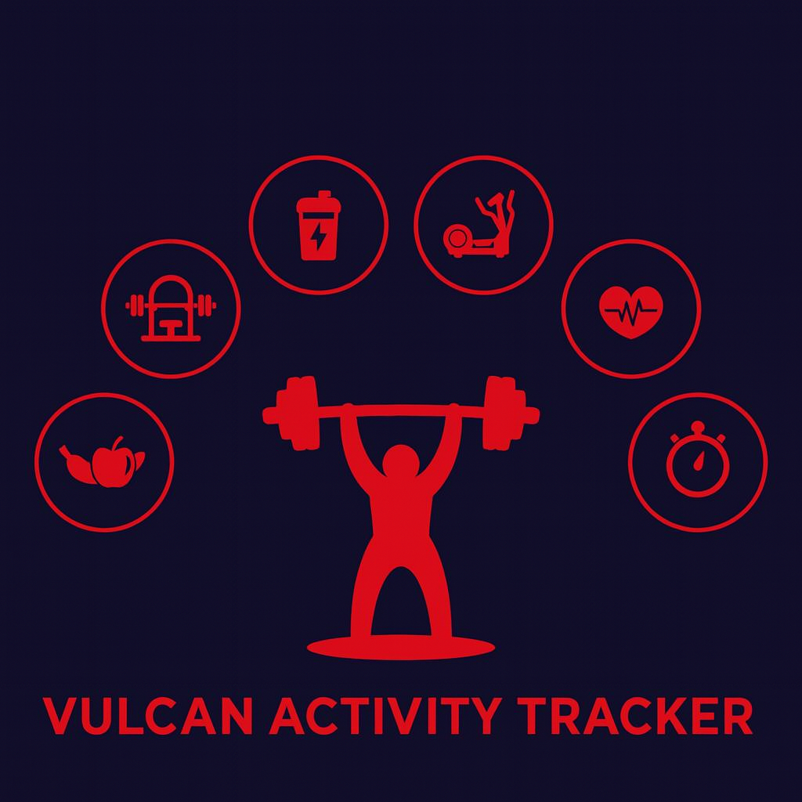

Week 10
Team Members:
Margo Bonal
John Gerega
Luke Ruffing

Professor: Dr. Weifeng Chen

Course: CMSC-4920-Senior Project II
School: Pennsylvania Western University

Table of Contents

Project: Vulcan Activity Tracker 1
Goals Accomplished: 2
Team Progress: 3
Gantt Chart: 4
Week 12 Plan: 4
Member Contribution: 5

Project: Vulcan Activity Tracker
As we near the end of the Spring 2026 semester, our Senior Project team viewed this week as both finalization and heavy development. Features were both built and polished. Overall debugging was held to ensure that remaining bugs were resolved. User study was additionally held to ensure that the Vulcan Activity Tracker meets both set requirements and usability. Several goals were set for this week to maintain proper schedule.

Goals Accomplished:
The first goal accomplished was the completion of the friend’s feature. There were a few components that were remaining since they required waiting for other pages development. For example, the friends feature now displays total counts of clubs, activities, and friends on the profile tag. This allows a user to see what kind of participation their friend had or has interacted with. The completion of this goal also resulted in construction of server-side components.
Ui updates were the second main goal of the week. Ensuring that all pages and scaling matched was very important to us. The overall experience of the Vulcan Activity Tracker is of highest priority since user impression determines how our app is perceived. Work was done to correct the settings page formatting and propagate fields from the server’s database.
Additional development was made to the challenges and team pages. Mini team dashboards were simulated to give coaches managerial options. Team features have been limited to coaches only, verified by emails. Challenges now have increased social interaction. Top three challenge participants are ranked with gold, silver bronze medals. Challenges also have their own mini leaderboard. All these components of the Vulcan Activity Tracker allow for users to both have fun exercise logging abilities and participate in fun competitions with other platform users. Through these features, we believe the Vulcan Activity Tracker meets the goal of promoting athletic and community-based campus interaction.
The last goal of week 11 was the registration of Azure Student Hosting account. This tool has a steep learning curve; therefore, our team has decided to start early enough to account for experimentation. Since we are on the Student Subscription, with 100 free credits, we will not be able to test the hosting until later in the semester (approximately 3 weeks from presentation). Azure hosting will give us a public domain. Once this is received, email verification can be finished.

Challenges Faced:
Solutions:

Team Progress:
Our team made substantial progress over the past week. The encroaching deadline is motivating us to move forward with the same development pace. Hosting and email completion might prove to be our most difficult piece yet. Therefore, we need to stay on schedule. We are on track with the Gantt chart in overall progress.

Gantt Chart:
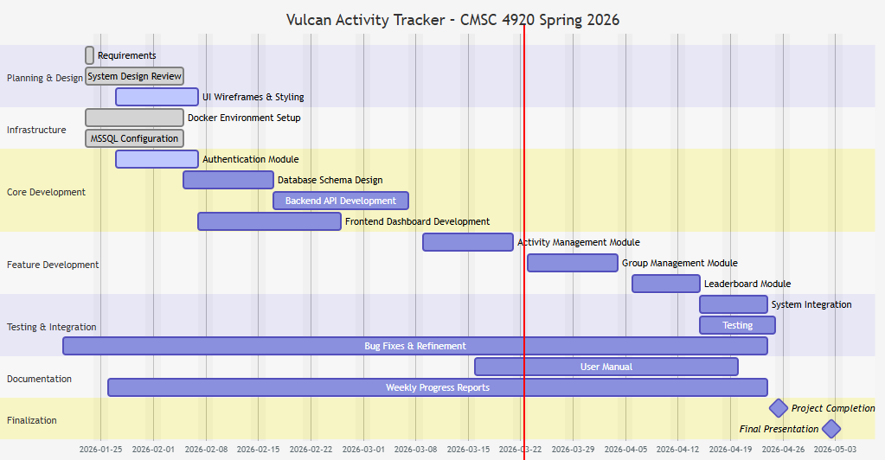

Week 12 Plan:
Our current plan for week 12 will be to finalize components. With roughly 4 weeks of development time left, we need to move to the next stages in our project. This will be the completion of the app, finalization, and overall debugging process. We need to allow for time for testing to ensure that all features work properly. Azure Student hosting will also take time to for initialization and launch process. Final steps will also be to complete the email feature. While our timeline is encroaching, our team is prepared to finish the semester strong! The Vulcan Activity Tracker will be transforming from concept to actuality in the next few weeks!

Member Contribution:

Team Members
Margo Bonal: | - Team meetings, Week 11 Report & Slides, Website development, hosting research, profile page
John Gerega: | - Team meetings, Week 11 report and slides, teams page, user profile page
Luke Ruffing: | - Team meeting, Week 11 Report & Slides, Challenges page

